CMP 4271

# Task: Play Testing.

## 5.1 Game Premise

The task was to develop qualitative and quantitative assessment and evaluation strategies for a serious online game. This was achieved by creating a questionnaire to help evaluate the quality of the game as a serious game.

## Reflection.

The best way to evaluate and assess games and the players is to approach it statistically. The members of the team accomplished this by creating a questionnaire that evaluated the educational quality of the game.

The game that the team chose was Minecraft. At first glance, Minecraft looked like a game that was better suited for casual gameplay and had no value besides entertainment but after further research by the team, it was discovered that the game holds educational value.

“Minecraft is educational because it enhances creativity, problem-solving, self-direction, collaboration, and other life skills.” (Aurora, 2016)

“Playing Minecraft teaches kids useful skills. The most clearly visible are visuospatial reasoning skills—learning how to manipulate objects in space in a way that helps them create dynamic structures.” (Atlantic, 2014)

The questionnaire approach was used to understand the educational value of the game in the eyes of the players. The approach took both the qualitative and quantitative aspects.

Figure 5.1. First Quantitative Analysis. This figure shows how often the users play the game Minecraft.

The first question was to find out how often people played the game, to gauge the credibility of information given by the players, because people who play Minecraft often will have noticed a significant increase in their skills in-game and their skills outside the game, while those who played the game once in a blue moon will not notice the changes.

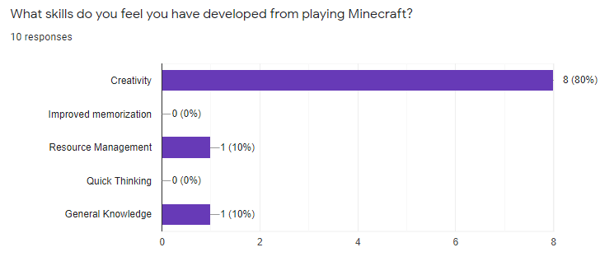

Figure 5.2. Second Quantitative Analysis. This figure shows the skills the users noticed they have developed after playing Minecraft as provided by the team.

The next question was made to determine what skills the players developed or improved upon. Majority of the users selected creativity, although it is hard to tell if that was the only skill that they developed as there was an error in the questionnaire that did not allow the users to select more than one option.

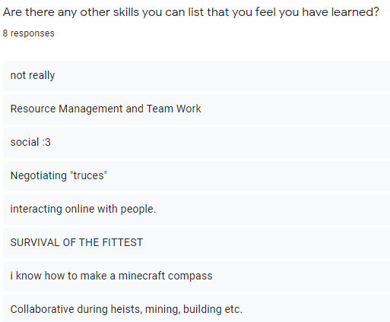

Figure 5.3. First Qualitative Analysis. This figure shows the other skills that players noticed they developed.

Another approach the team took was qualitative analysis, were the users were allowed to relay the skills that they feel they have learned from playing the game. In summary, the users determined that they have gained communication, teamwork and creative skills during the course of continued gameplay.

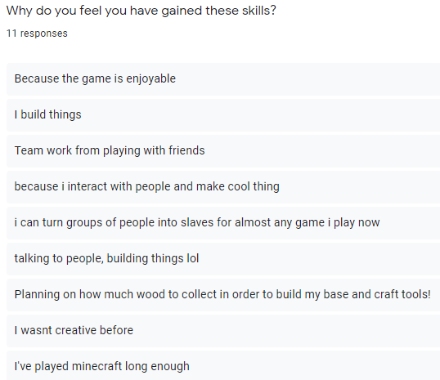

Figure 5.4. Second Qualitative Analysis. This figure shows the reasons the users continued to play the game as they developed their skills.

The reason behind this is because the game takes fun approach at skill development that the users did not realise they were gaining skills until they compared their progress overtime.

In the future, this process would be more favourable with more quantitative and qualitative analysis that targets a wider group of people for a broader comparison.